## Creating Data Visualizations using ggplot



**Objective for Exercise**

We will create different data visualizations using the ggplot package using the inbuilt dataset in R called mtcars

1. Click on the + symbol on the top left and choose R Script from the menu to open a new R edit window in RStudio:

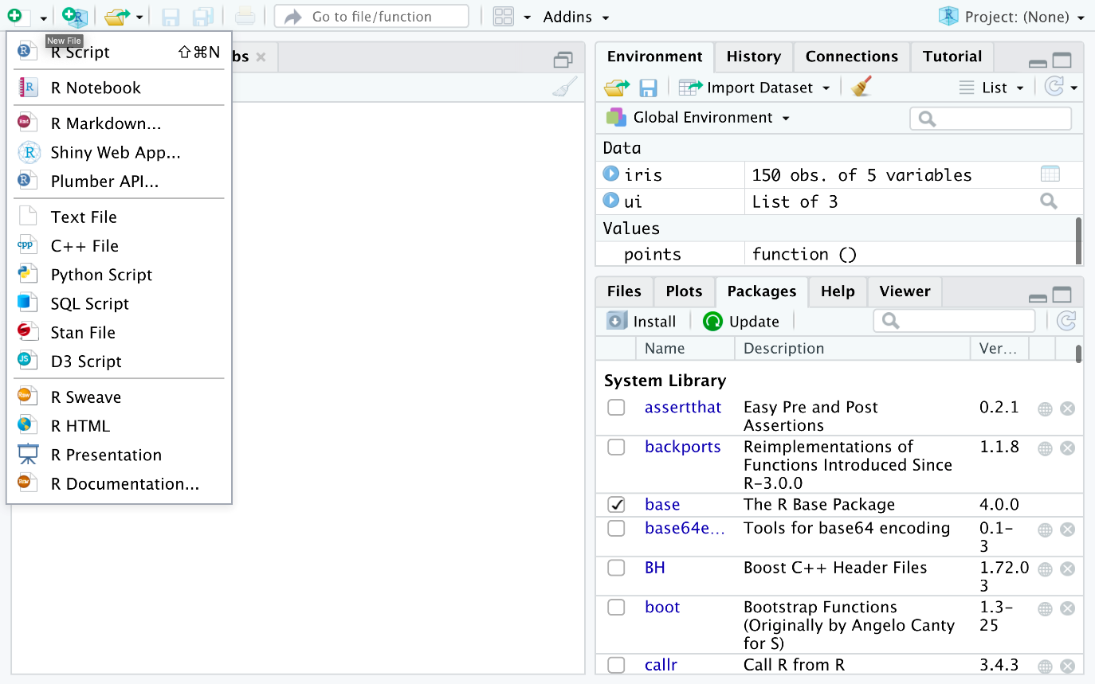

1. Read and view the first 5 rows of the Data using the following:
2. 1
3. 2
4. 3
5. 4
6. 5
7. 6
8. 7
9. 8
10. 9
11. library(datasets)
12. #Load Data
13. data(mtcars)
14. #View first 5 rows
15. head(mtcars, 5)

Copied!

1. Type this ?mtcars to get information about the variables. This will print the information at the bottom right panel, on the Help tab
2. Copy and paste the following code to load the ggplot package and create a scatterplot of disp and mpg.
3. 1
4. 2
5. 3
6. 4
7. 5
8. 6
9. #load ggplot package
10. library(ggplot2)
11. #create a scatterplot of displacement (disp) and miles per gallon (mpg)
12. ggplot(aes(x=disp,y=mpg,),data=mtcars)+geom_point()

Copied!

1. Use the following code to add a title.
2. 1
3. 2
4. 3
5. 4
6. #Add a title
7. ggplot(aes(x=disp,y=mpg,),data=mtcars)+geom_point()+ggtitle("displacement vs miles per gallon")

Copied!

1. Use the following code to change the name of the x-axis and y-axis
2. 1
3. 2
4. 3
5. 4
6. #change axis name
7. ggplot(aes(x=disp,y=mpg,),data=mtcars)+geom_point()+ggtitle("displacement vs miles per gallon") + labs(x = "Displacement", y = "Miles per Gallon")

Copied!

1. Use the following to create a boxplot of the the distribution of mpg for the individual Engine types vs Engine (0 = V-shaped, 1 = straight)  
   To do this you have to make vs a string or factor.
2. 1
3. 2
4. 3
5. 4
6. 5
7. 6
8. #make vs a factor
9. mtcars$vs <- as.factor(mtcars$vs)
10. #create boxplot of the distribution for v-shaped and straight Engine
11. ggplot(aes(x=vs, y=mpg), data = mtcars) + geom_boxplot()

Copied!

1. Add color to the boxplots to help differentiate:
2. 1
3. 2
4. 3
5. ggplot(aes(x=vs, y=mpg, fill = vs), data = mtcars) +
6. geom_boxplot(alpha=0.3) +
7. theme(legend.position="none")

Copied!

1. Finally, let us create the histogram of weight wt.
2. 1
3. ggplot(aes(x=wt),data=mtcars) + geom_histogram(binwidth=0.5)

Copied!

This concludes this lab, we hope that you had fun!

## Author(s)

[Aije Egwaikhide](https://www.linkedin.com/in/aije-egwaikhide/)

## Change log

| **Date** | **Version** | **Changed by** | **Change Description** |
| --- | --- | --- | --- |
| 2023-05-04 | 1.1 | Benny | Added page numbers and republished |
| 2020-12-14 | 1.0 | Aije | Created initial version of the lab |